**SIDS TO SUICIDE**

Cytochrome P450

**The missing piece-the common thread of**

SIDS, Autism, Tylenol, Suicide, Homicide

**What is Cytochrome P450**

Cytochrome P450 (CYP450) refers to a superfamily of enzymes primarily located in the liver, but also present in the intestines, lungs, kidneys, mitochondria and other tissues. These enzymes play a central role in the phase I metabolism of endogenous compounds (e.g., hormones, fatty acids) and exogenous substances (e.g., drugs, environmental toxins, vaccine excipients and xenobiotics).

The primary function of CYP450 enzymes is facilitating their subsequent elimination via phase II conjugation and renal or biliary excretion. They are responsible for the biotransformation of approximately 70–80% of clinically used drugs and are apparently involved in excreting vaccine excipients.

: 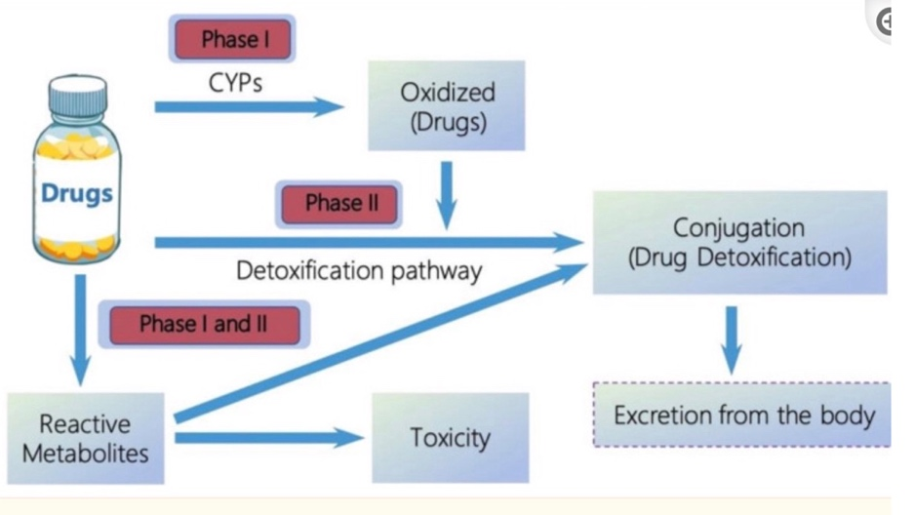

**Key enzymes include:**

**CYP3A4** – the most abundant and clinically significant, involved in the metabolism of over 50% of drugs.

**CYP2D6**, **CYP2C9**, **CYP2C19**, and **CYP1A2** – other major contributors to drug metabolism.

**CYP2E1** – notable for its role in metabolizing ethanol and activating certain procarcinogens.

**IMMATURITY OF CYP450 IN INFANTS**

The immaturity of cytochrome P450 (CYP450) enzymes in infants and young children limits their capacity to detoxify vaccine excipients and adjuvants such as aluminum, mercury, formaldehyde, and polysorbate 80, ethanol, and more…

At birth, CYP450 enzyme activity is significantly underdeveloped. While some enzymes, like CYP3A4, begin to mature within the first year of life, others—such as CYP2C9 and CYP2D6—may not reach adult levels until ages 5 to 10. Full metabolic capacity typically isn’t achieved until after age three. During this developmental window, repeated exposure to vaccine components can result in their accumulation, potentially crossing the blood-brain barrier and contributing to adverse neurological outcomes, including regressive autism.

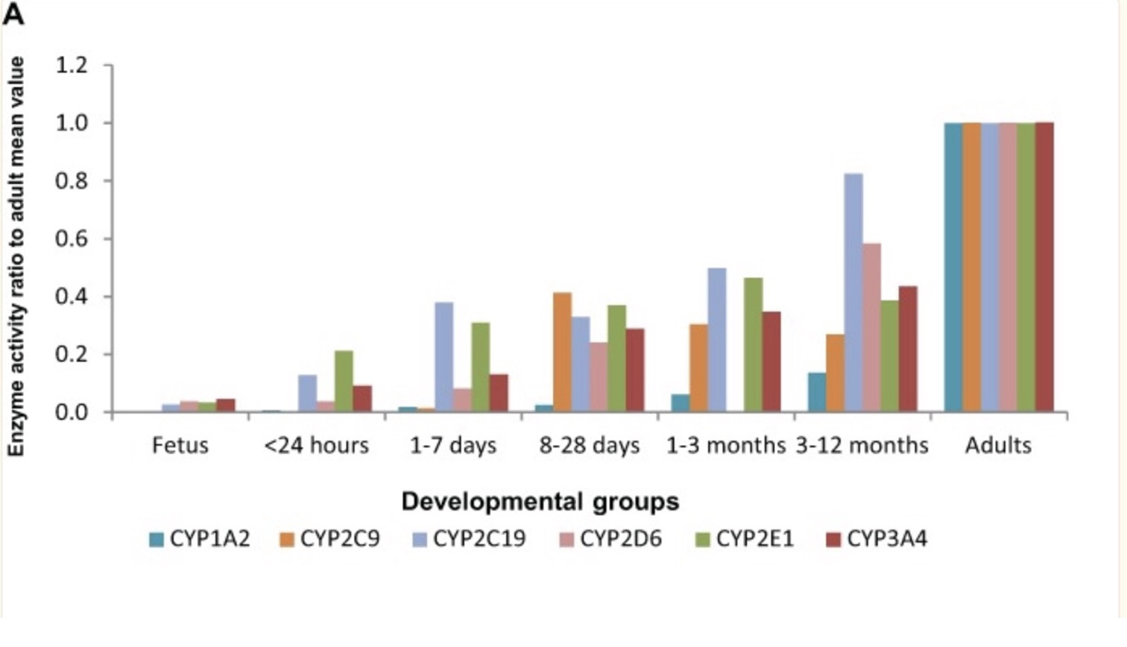

Genetic “polymorphisms” (no activity of a specific enzyme) further influence CYP450 activity, explaining why some children experience severe vaccine reactions while others do not. Ethnicity, inherited gene variants, and epigenetic factors can all affect how efficiently these enzymes process and clear toxins. Individuals with impaired CYP450 function—especially involving genes like *CYP2E1*or *CYP2D6*—are more susceptible to environmental toxins and may face heightened risks from both vaccines and medications.

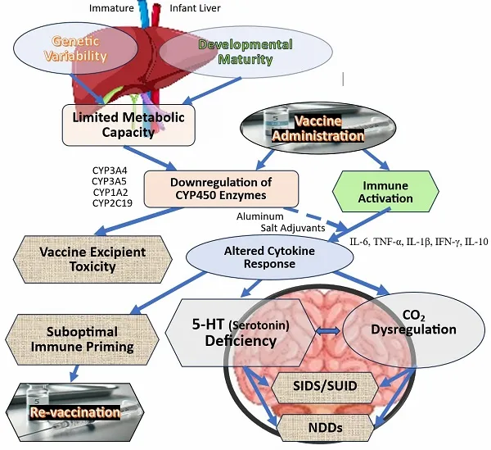

<https://childrenshealthdefense.org/defender/vaccines-toxic-ingredients-sids-some-infants-study/?utm_id=20250603>

*Study by Dr. Gary Goldman: [**The Immature Infant Liver: Cytochrome P450 Enzymes and their Relevance to Vaccine Safety and SIDS Research**](https://pmc.ncbi.nlm.nih.gov/articles/PMC12080585/?)

____________________________________________________________________________________________________________________________________________________________

**TYLENOL and Cyp 450**

Tylenol ([acetaminophen](https://www.google.com/search?client=safari&rls=en&q=acetaminophen&ie=UTF-8&oe=UTF-8&mstk=AUtExfDw9EzFGV2ST_TBtC7vCNKUlJnJDGtSKAexVEyo2kYQBbV_AB47dIeDknjqzO4-1H9tF34yUx3n9ttC80l7-yl3K7Oyb-fNEblBZhKYngXI0j_8KUaF2dP2xKDeqVA8-6X3pGo65bn7UmaX8JNOnqbJtfXsA1DJ0uU5iW5Melk6uw8&csui=3&ved=2ahUKEwi__dfLteyPAxUPlokEHfHFAFYQgK4QegQIARAE)) is processed by Cytochrome P450 (CYP) enzymes, specifically [CYP1A2](https://www.google.com/search?client=safari&rls=en&q=CYP1A2&ie=UTF-8&oe=UTF-8&mstk=AUtExfDw9EzFGV2ST_TBtC7vCNKUlJnJDGtSKAexVEyo2kYQBbV_AB47dIeDknjqzO4-1H9tF34yUx3n9ttC80l7-yl3K7Oyb-fNEblBZhKYngXI0j_8KUaF2dP2xKDeqVA8-6X3pGo65bn7UmaX8JNOnqbJtfXsA1DJ0uU5iW5Melk6uw8&csui=3&ved=2ahUKEwi__dfLteyPAxUPlokEHfHFAFYQgK4QegQIARAF), [CYP2E1](https://www.google.com/search?client=safari&rls=en&q=CYP2E1&ie=UTF-8&oe=UTF-8&mstk=AUtExfDw9EzFGV2ST_TBtC7vCNKUlJnJDGtSKAexVEyo2kYQBbV_AB47dIeDknjqzO4-1H9tF34yUx3n9ttC80l7-yl3K7Oyb-fNEblBZhKYngXI0j_8KUaF2dP2xKDeqVA8-6X3pGo65bn7UmaX8JNOnqbJtfXsA1DJ0uU5iW5Melk6uw8&csui=3&ved=2ahUKEwi__dfLteyPAxUPlokEHfHFAFYQgK4QegQIARAG), and [CYP3A4](https://www.google.com/search?client=safari&rls=en&q=CYP3A4&ie=UTF-8&oe=UTF-8&mstk=AUtExfDw9EzFGV2ST_TBtC7vCNKUlJnJDGtSKAexVEyo2kYQBbV_AB47dIeDknjqzO4-1H9tF34yUx3n9ttC80l7-yl3K7Oyb-fNEblBZhKYngXI0j_8KUaF2dP2xKDeqVA8-6X3pGo65bn7UmaX8JNOnqbJtfXsA1DJ0uU5iW5Melk6uw8&csui=3&ved=2ahUKEwi__dfLteyPAxUPlokEHfHFAFYQgK4QegQIARAH), which convert it to a toxic byproduct called NAPQI (N-acetyl-p-benzoquinone-imine).

**NAPQI (N-acetyl-p-benzoquinone imine) toxicity**

occurs from an overdose of acetaminophen (APAP), which is a common occurrence in pregnancy. While NAPQI does not cross the placenta, the parent compound, APAP, does, posing a risk of liver damage to both the mother and the fetus. Fetal risk increases after 14 weeks gestation when the fetal liver begins metabolizing APAP into NAPQI

* **Normal APAP metabolism:** At therapeutic doses, acetaminophen is metabolized in the liver and detoxified by glutathione.
* **Overdose:** In an overdose, the glutathione supply is exhausted, and the APAP is shunted to the cytochrome P450 (CYP450) system, which produces the toxic metabolite NAPQI.
* **Cellular damage:** In the absence of sufficient glutathione, NAPQI binds to and damages liver cells, leading to severe hepatotoxicity, acute liver failure, and potentially death.
* **Fetal susceptibility:**
  + The fetus can produce its own NAPQI starting around 14 weeks gestation and has a limited supply of glutathione, making it vulnerable to APAP's effects.
  + The fetal liver's CYP450 activity increases with gestational age, peaking in the third trimester.

**Maternal effects**

* **Hepatic:** Liver injury, fulminant hepatic failure, liver transplant, and death.
* **Other organs:** Renal failure and pancreatitis.
* **Gastrointestinal:** Nausea, vomiting, anorexia, and abdominal pain.
* **Neurological:** Hepatic encephalopathy and confusion.

**Fetal effects**

* **Fetal hepatotoxicity:** The fetus's developing liver can suffer direct damage, especially in the third trimester.
* **Fetal death:** Overdose can lead to spontaneous abortion and fetal demise in all trimesters, with late presentation of maternal toxicity being a significant risk factor.
* **Premature birth:** Acetaminophen overdose can induce premature labor.
* **Neurodevelopmental:** Some studies suggest an association between prenatal APAP exposure at therapeutic doses and an increased risk of ADHD and other neurodevelopmental disorders, but data remains observational

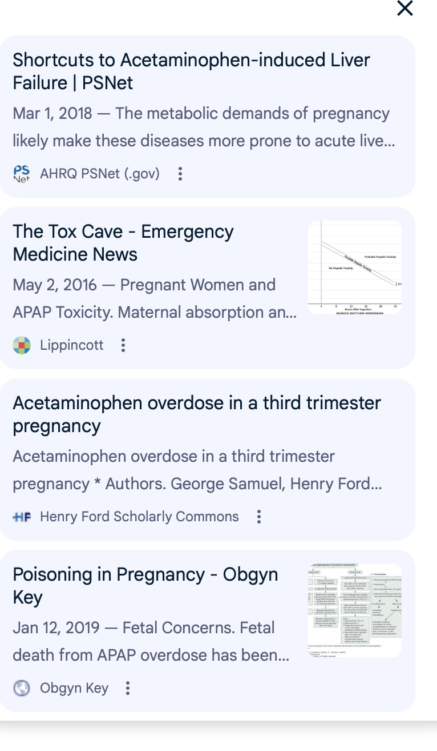

**MENTAL HEALTH, SUICIDES AND HOMICIDES**

Beyond early childhood, pharmacogenetic variability continues to impact drug metabolism throughout life. Ineffective detoxification can lead to toxin accumulation, contributing to neurological and psychiatric conditions such as ADHD, depression, bipolar disorder, OCD, and even more severe outcomes. Emerging evidence suggests that impaired CYP450 function may play a role in the rising incidence of mental health disorders, suicides, and violent behaviors, particularly in individuals exposed to both environmental toxins and psychiatric drugs.

**EXAMPLE:**

Adam Lanza exhibited signs of developmental challenges from an early age, including communication deficits, sensory sensitivities, delayed socialization, and repetitive behaviors—all commonly associated with autism spectrum disorder. He was later diagnosed with Asperger's syndrome.

Lanza was treated by Dr. Robert King, who recommended comprehensive support services and prescribed the antidepressant **Celexa** (citalopram). However, after taking the medication for just three days, Lanza experienced severe adverse reactions. According to his mother, he became dizzy, disoriented, and cognitively impaired, unable to perform basic tasks such as opening a cereal box. He also suffered from profuse sweating and nearly vegetative behavior. As a result of these alarming side effects, the medication was discontinued. The severity of Lanza’s response strongly suggests that **Celexa was contraindicated** for his specific biological profile.

Celexa (citalopram) is primarily metabolized in the liver by the **CYP2C19** enzyme, with additional involvement from **CYP3A4** and **CYP2D6**, all part of the **Cytochrome P450 enzyme family**. Pharmacogenetic studies have demonstrated a significant relationship between CYP2C19 genetic variations and a patient's ability to metabolize citalopram and escitalopram effectively. Individuals with certain genetic profiles, such as **CYP2C19*2 or 3* (loss-of-function alleles) or **CYP2C19*17** (gain-of-function allele), may experience altered drug exposure, resulting in either drug accumulation or ineffective treatment—both of which can lead to severe psychiatric consequences.

Both **prescription and recreational drugs** are metabolized by the **Cytochrome P450 enzyme system**, whose successful detoxification is subject to individual **genetic variability**.

